Saint Luke Lutheran Church
Eighteenth Sunday after Pentecost

Sunday, October 12, 2025
The Reverend Dr. Christian Eichorn, Pastor

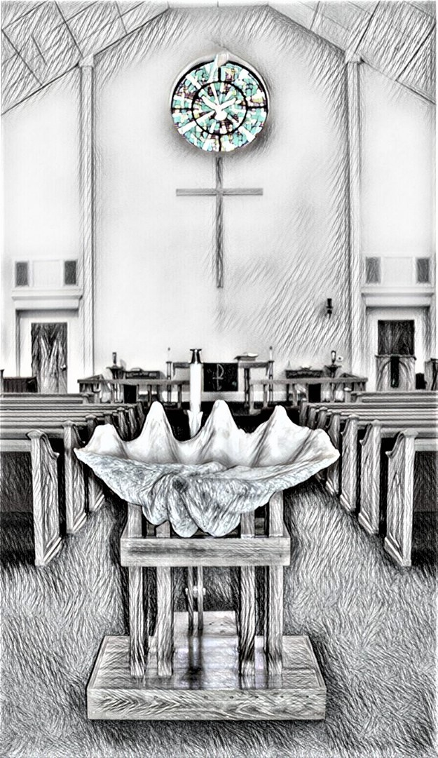

SAINT LUKE WELCOMES
ALL TO WORSHIP!

We are grateful for your presence in today’s worship! Your participation truly makes a difference. We hope you feel
encouraged, blessed, and welcomed!

In preparation for worship, please
silence all electronic devices when
entering the sanctuary in reverence
to God and respect for others.

Members and visitors ~
kindly remember to sign in using the
friendship binders in your pew.

The altar flowers are given to the
Glory of God and in celebration of
Dan & Deb Mardis’ 50th Wedding Anniversary
INTRODUCTION TO THE DAY
It’s a miracle! Multiple miracles! The waters of holy baptism have healed us. The body and blood of Jesus in holy communion have made us clean. We have died with Christ and been raised with him. For all this we have returned to offer thanks. From this place we are sent on our way rejoicing to share the good news.

PRESERVICE MUSIC
Introduction of Liturgy Setting Ten ~ Joan Eccard

WELCOME
PRELUDE “God of the Sparrow”, Carl Schalk, arr. Karen Thompson.
St. Luke Handbell Choir, Kiim Hawkins, Conductor.
©2008 GIA Publications.

Congregation stands
CONFESSION AND FORGIVENESS
P Blessed be the Holy Trinity, ☩ one God, who forgives all our sin, whose mercy endures forever.
C Amen.
P Almighty God, to whom all hearts are open, all desires known, and from whom no secrets are hid: cleanse the thoughts of our hearts by the inspiration of your Holy Spirit, that we may perfectly love you and worthily magnify your holy name, through Jesus Christ our Lord.
C Amen.
P Gracious God,
C have mercy on us. We confess that we have turned from you and given ourselves into the power of sin. We are truly sorry and humbly repent. In your compassion forgive us our sins, known and unknown, things we have done and things we have failed to do. Turn us again to you, and uphold us by your Spirit, so that we may live and serve you in newness of life through Jesus Christ, our Savior and Lord. Amen.
P God, who is rich in mercy, loved us even when we were dead in sin, and made us alive together with Christ. By grace you have been saved. In the name of ☩ Jesus Christ, your sins are forgiven. Almighty God, strengthen you with power through the Holy Spirit, that Christ may live in your hearts through faith.
C Amen.

GATHERING HYMN “Love Divine, All Loves Excelling”, #631

APOSTOLIC GREETING
P The grace of our Lord Jesus Christ, the love of God, and the communion of the Holy Spirit be with you all.
C And also with you.

HYMN OF PRAISE “Gloria” S-204a (Front of hymnal, page 204)

PRAYER OF THE DAY
WA Let us pray.
C Almighty and most merciful God, your bountiful goodness fills all creation. Keep us safe from all that may hurt us, that, whole and well in body and spirit, we may with grateful hearts accomplish all that you would have us do, through Jesus Christ, our Savior and Lord. Amen.
Congregation sits
FIRST READING ~ Habakkuk 5:1-3, 7-15c
L The Word of the Lord.
C Thanks be to God.

PSALM ~ Psalm 111
L ¹ Hallelujah! I will give thanks to the Lord with my whole heart, in the assembly of the upright, in the congregation.
C ² Great are your works, O Lord, pondered by all who delight in them.
L ³ Majesty and splendor mark your deeds, and your righteousness endures forever.
C ⁴ You cause your wonders to be remembered; you are gracious and full of compassion.
L ⁵ You give food to those who fear you, remembering forever your covenant.
C ⁶ You have shown your people the power of your works in giving them the lands of the nations.
L ⁷ The works of your hands are faithfulness and justice; all of your precepts are sure.
C ⁸ They stand fast forever and ever, because they are done in truth and equity.
L ⁹ You sent redemption to your people and commanded your covenant forever; holy and awesome is your name.
C ¹⁰ The fear of the Lord is the beginning of wisdom; all who practice this have a good understanding. God’s praise endures forever.

SECOND READING ~ 2 Timothy 2:8-15
L The word of the Lord.
C Thanks be to God.

Congregation stands
“Alleluia” S-205a (Front of hymnal, page #205)
(Music on next page)
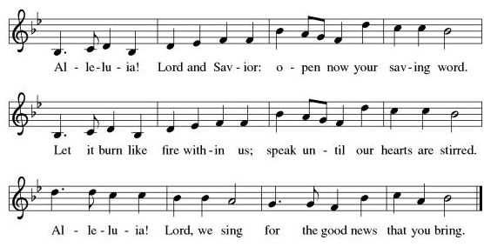
GOSPEL ~ Luke 17:11-19
P The Holy Gospel according to St. Luke.
C Glory to you, O Lord.
P The Gospel of the Lord.
C Praise to you, O Christ.

Congregation sits
+ SERMON + THE REVEREND DR. CHRISTIAN EICHORN +
Silence for reflection
Congregation stands

hymn of the day “Remember and Rejoice”, #454

“The APOSTLE’s CREED” S-105 (Front of hymnal, page #105)

PRAYERS OF INTERCESSION
P Renewed in God’s everlasting grace, let us pray for the church, the world, and all creation.
WA …God of grace,
C Receive our prayer.
P We offer our prayers, O God, trusting in your everlasting grace and mercy, through Jesus Christ our Lord.
C Amen.
PEACE & SHARE THE PEACE OF THE LORD
P The peace of Christ be with you always.
C And also with you.
Congregation sits
OFFERTORY “Give Me a Vessel”, Stan Pethel & Julie Myers.
St. Luke Voice Choir.
©2009 Lorenz.

Congregation stands
OFFERING HYMN “Let the Vinyards Be Fruitful”, #184

OFFERING PRAYER
P Let us pray. Lord of the harvest,
C we return to you a portion of what you have given to us. Turn us to set our hope not on the uncertainty of riches, but on you, who richly provides for us. Multiply what we have gathered to bless all who are suffering and in need, through Jesus Christ our Lord. Amen.

“THE GREAT THANKSGIVING” S-206 (Front of hymnal, page #206)
P The Lord be with you.
C And also with you.
P Lift up your hearts.
C We lift them to the Lord.
P Let us give thanks to the Lord our God.
C It is right to give our thanks and praise.
P …we praise your name and join their unending hymn:
“Holy, Holy, Holy” S-207 (Front of hymnal, page #207)
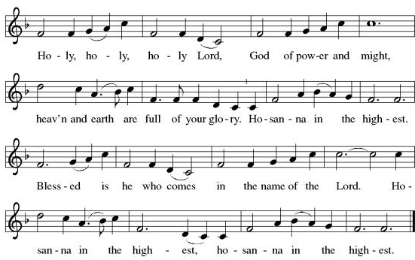
P …For as often as we eat of this bread and drink from this cup, we proclaim the Lord’s death until he comes.
C Christ has died. Christ is risen. Christ will come again.
P …And, believing the witness of his resurrection, we await his coming in power to share with us the great and promised feast.
C Amen. Come, Lord Jesus.
P Send now, we pray, your Holy Spirit, that we who share in Christ’s body and blood may live to the praise of your glory and receive our inheritance with all your saints in light.
C Amen. Come, Holy Spirit.
P Join our prayers with those of your servants of every time and every place, and unite them with the ceaseless petitions of our great high priest until he comes as victorious Lord of all.
C Through him, with him, in him, in the unity of the Holy Spirit, all glory and honor is yours, almighty Father, now and forever. Amen.
P Lord, remember us in your kingdom and teach us to pray.
C Our Father, who art in heaven, hallowed be thy name, thy kingdom come, thy will be done, on earth as it is in heaven. Give us this day our daily bread; and forgive us our trespasses, as we forgive those who trespass against us; and lead us not into temptation but deliver us from evil. For thine is the kingdom, and the power, and the glory, forever and ever. Amen.

INVITATION TO COMMUNION
P Jesus welcomes sinners and eats with them. Come to this meal of mercy.
C Thanks be to God.

Congregation sits
Distribution of the bread and wine Our communion is open to all who are baptized.

“lamb of god (Agnus Dei)” S-208 (Front of hymnal, page #208)
(music on next page)
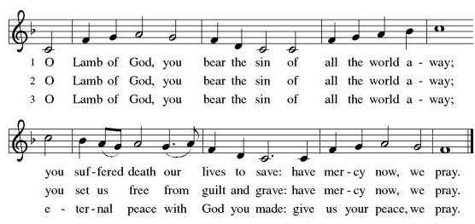
communion hymns
“O Christ, the Healer We Have Come”, #610
“There is a Balm in Gilead”, #614

Congregation stands
TABLE BLESSING
P The body and blood of our Lord Jesus Christ strengthen you and keep you in his grace.
C Amen.

“POST COMMUNION CANTICLE”, S-113
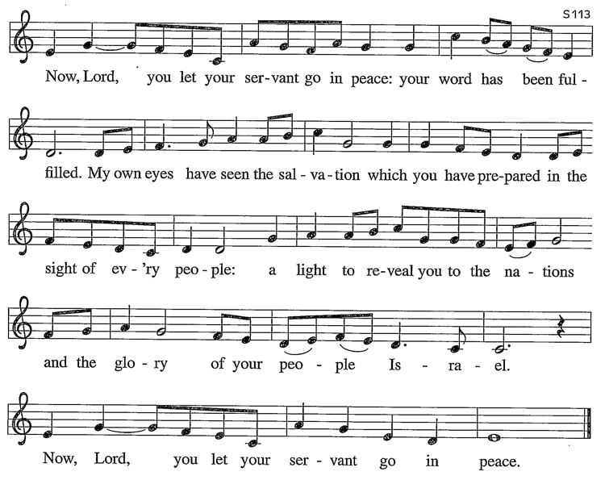
PRAYER AFTER COMMUNION
P …We ask this in Jesus’ name.
C Amen.

BLESSING
P The Lord bless you and keep you; the Lord make his face shine upon you, and be gracious to you, the Lord look upon you with favor, + and give you peace.
C Amen.

SENDING HYMN “I Heard the Voice of Jesus Say”, #611

DISMISSAL
WA Go in peace. Do not lose heart.
C Thanks be to God.

POSTLUDE
--Thank you for worshiping with us today—

The following members assisted with today’s worship service with live streaming:
Altar Guild: Lori Schneider, Dianne Ward | AV Team: Dan & Deb Mardis
Bulletin: Dawn Plyler ~ Cover Art: Lori Schneider | Cantor: Joan Eccard
Church Music: Bud Esper, Director of Music & Kim Hawkins, Conductor
Communion Assistants: Lori Schneider, Dianne Ward | Crucifer: Doug Snively Eucharistic Minister: Joyce Rivenburgh | Greeters: Joan Zimmermann, Joy Smith
Lector: Walt Eccard | Worship Assistant: Kristen Killoran
Ushers: Dan Mardis, Bob Moore, Kenn Nelson, Bob Regan

NEW MEMBERS
Are you looking for a new church family? We’d love to help you connect with others in the church and grow in our Faith Community together. If you are thinking about joining St. Luke, please contact Pastor Eichorn at 610.393.7622 or pastoreichorn@stlukeoib.org or the Church office.

ALTAR FLOWERS
Please contact the church office to sponsor Sunday altar flowers.
Upcoming availability: October 19; November 2(1vase),9,23,30

Prayer List October 12, 2025
Mary Mason, Robert Borchert, Jr. Nancy Rottger, Karen Hagy, Steve Jewell, Nancy Smith, Joseph Sesack, Sandra Abbondandelo, John M. Halliday, Ken Jobst, Rose Henshaw, Terri Boone, Rosemary Carlson, Jason Magalnick, Tom Shabluk, Mike Claxton, Mike Thesfeld, Joan Schlegel and the hostages and people of Gaza.

------------------------
For Your Information
WELCOME VISITORS ~ We are so delighted you came to Saint Luke today. Please join us in the Fellowship Hall after worship services for light refreshments and to say hello. We can’t wait to meet you!

MURDER IN THE WILD WEST DINNER SHOW ~ OCTOBER 16, 6pm ~ Friendly reminder to pick up an envelope from Judy today! This includes directions and tickets for the show.

LMM FALL CLEAN UP ~ SATURDAY, OCTOBER 18 ~ 9am – Noon or until done. Bring work gloves and your favorite hand tools. Projects planned: perimeter cleanup, columbarium cleanup and fall planting, grill cleanup, weeding, leaf blowing, trimming. All are welcome!

WOSL FALL FESTIVAL ~ OCTOBER 26 ~ Church members are invited to join us and bring their favorite pumpkin or apple dessert. Our theme this year will be “Pick your Favorite Team ~ Team Pumpkin or Team Apple.” Sign up on the community board by Sunday, October 19.

REMEMBERING OUR SAINTS ~ SUNDAY, NOVEMBER 2 ~ On All Saints Sunday, we will give thanks for the lives of the members of our congregation who have passed away since last year. We will honor them and any other loved ones during our remembrance time. If you would like to share the name(s) of a loved one, please contact the church office. All are welcome to speak a name during the service, even if you do not contact the office beforehand.

WOSL DINNER & MEETING ~ October 20, 5pm, FELLOWSHIP HALL ~ Join us for a delicious meal and learn about the activities available at the Senior Center. See you there! ~Joyce Charity.

WALK TO END HUNGER WITH US! ~ The Crop Hunger Walk (CHW) is fast approaching! Join us by walking or donating.
- Come together November 2 at 1pm at Mulberry Park in Shallotte.
- Choose a 1-mile or 5K walk. 75% of funds go to Crop Programs (10 countries). 25% stays local for The Lords Food Pantry.
- Can’t walk? You can still donate! Make checks to SLLC, memo line “CHW”.
SUPPORTING ST. LUKE MINISTRIES ~ Checks payable to SLLC with noted ministry.
- Columbarium project landscaping …any gift is welcome.
- New Hymnals … The cost is $35/each.
- Crop Hunger Walk 2025…any gift is welcome.
- Food Lion gift cards available in the Fellowship Hall after worship services.
- TLFP ~ 170 cans received to date/goal is 250. Cran, you help?
- Prayer Shawl Group ~ accepting donations of yarn. Drop off in the Fellowship Hall in the labeled box.
SAINT LUKE WELCOMES GUEST PASTORS RAY & RUTH ANN SIPE ~ Lutheran Disaster Response of the Carolina’s Directors, Pastors Ray & Ruth Ann Sipe will join us Sunday, November 9. They will discuss those who are interested in preparing for disasters at home and at church. A home preparedness presentation will take place during Sunday School and church preparedness immediately following the service. More information is forthcoming.

This Week at Saint Luke ~ October 2025
Sunday, October 12 9am Adult Sunday School
Eighteenth Sunday after Pentecost 10am Worship Service with live streaming
11am Fellowship
Monday, October 13 3pm MexTrain
Tuesday, October 14 10:30am Listening Group
11am Social Committee Meeting ~ Library
1pm Bridge
Wednesday, October 15 10am Prayer Service
6pm Handbell Choir
7pm Voice Choir
Thursday, October 16 1pm Church Council ~ Library
6pm Murder in the Wild West Dinner & Show
Friday, October 17 11am Worship & Music Committee ~ Library
Saturday, October 18 9am-Noon Fall Clean Up
Sunday, October 19 9am Adult Sunday School
Nineteenth Sunday after Pentecost 10am Worship service with live streaming
The Baptism of Waylon Langenberg
11am Fellowship with cake celebrating “Waylon”

Scripture Readings ~ October 19, 2025 ~ Nineteenth Sunday after Pentecost
Genesis 32:22-31 | Psalm 121 | 2 Timothy 3:14-4:5 | Luke 18:1-8

ST LUKE LUTHERAN CHURCH
5869 Ocean Highway West, Ocean Isle Beach NC 28469

main: 910.579.0107 | email: stlukeelca@stlukeoib.org | website: stlukeoib.org
office hours: Monday through Thursday, 9:00am to 2:00pm
The Reverend Dr. Christian Eichorn, Pastor | cell/text: 610.393.7622 | email:pastoreichorn@stlukeoib.org
Kristen Killoran, Worship Assistant | Pam Eichorn, Worship Assistant
Bud Esper, M.A., Director of Music | stlukemusic@stlukeoib.org
Dawn Plyler, Parish Administrator | main: 910.579.0107 | email: stlukeelca@stlukeoib.org
Portions recorded by permission under One License #A-729360. All rights reserved. Portions from sundaysandseasons.com.
Portions copyright ©2020 Augsburg Fortress. All rights reserved.

