Saint Luke Lutheran Church
Fourth Sunday in Lent
Sunday, March 15, 2026
The Reverend Dr. Christian Eichorn, Pastor

SAINT LUKE WELCOMES
ALL TO WORSHIP!

We are grateful for your presence in today’s worship! Your participation truly makes a difference. We hope you feel
encouraged, blessed, and welcomed!

In preparation for worship, please
silence all electronic devices when
entering the sanctuary in reverence
to God and respect for others.

~ Members and visitors ~
kindly remember to sign in using the
friendship binders in your pew.

The altar flowers are given
to the glory of God and in grateful dedication to the artistry of Karen Ernst, whose handmade banners gracefully
adorn Saint Luke Lutheran Church.

INTRODUCTION TO THE DAY
Baptism is sometimes called enlightenment. The gospel for this Sunday is the story of the man born blind healed by Christ. “I was blind, now I see,” declares the man. In baptism God opens our eyes to see the truth of who we are: God’s beloved children. As David was anointed king of Israel, in baptism God anoints our head with oil, and calls us to bear witness to the light of Christ in our daily lives.

PRESERVICE MUSIC
"Columcille" (Trad. Irish melody, hymn: "No Wind at the Window"), arr. Anne Krentz Organ. Bud Esper, organ.
©2004 Augsburg Fortress.

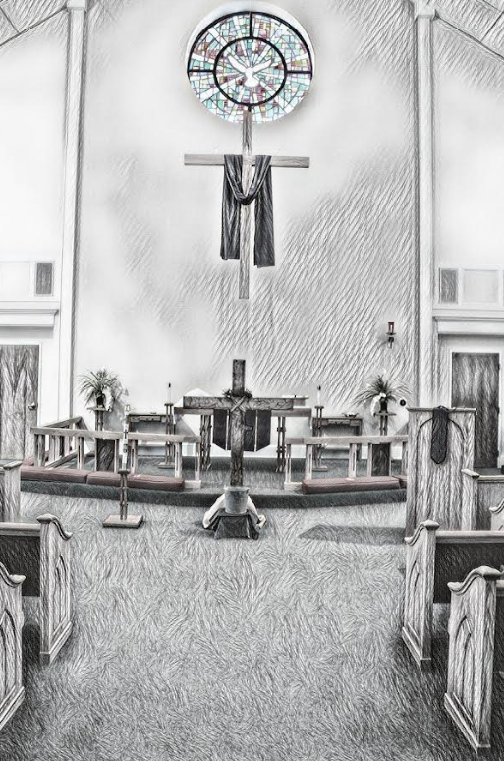
WELCOME & PRELUDE "Love Will Find a Way", Dan Edwards. St. Luke Handbell Choir, Kim Hawkins, conductor. ©2010 Lorenz Publishing.

Congregation stands
CONFESSION AND FORGIVENESS
P Almighty God, …your holy name, through Jesus Christ our Lord.
C Amen.
P Gracious God,
C have mercy on us. We confess that we have turned from you and given ourselves into the power of sin. We are truly sorry and humbly repent. In your compassion forgive us our sins, known and unknown, things we have done and things we have failed to do. Turn us again to you, and uphold us by your Spirit, so that we may live and serve you in newness of life through Jesus Christ, our Savior and Lord. Amen.
P …Holy Spirit, that Christ may live in your hearts through faith.
C Amen.

GATHERING HYMN “Guide Me Ever, Great Redeemer”, #618

APOSTOLIC GREETING
P The grace of our Lord Jesus Christ, the love of God, and the communion of the Holy Spirit be with you all.
C And also with you.

KYRIE S-203 (Front of hymnal, page S-203)

PRAYER OF THE DAY
WA Let us pray.
C Bend your ear to our prayers, Lord Christ, and come among us. By your gracious life and death for us, bring light into the darkness of our hearts, and anoint us with your Spirit, for you live and reign with the Father and the Holy Spirit, one God, now and forever. Amen.

BLESSING OF LENT AND PALM SUNDAY BANNERS
P Sisters and brothers, …these banners to the glory of God.
P Let us pray.
C We give you thanks, O God, creator of the universe, for you have enriched our lives with every good and perfect gift; you have commanded us to show your splendor to our children; and you have invited us to praise you with lives of love, justice, and joy.
P …in the unity of the Holy Spirit, now and forever.
C Amen.

Congregation sits
FIRST READING 1 Samuel 16:1-13
L The Word of the Lord.
C Thanks be to God.

PSALM 23
L ¹ The Lord is my shepherd; I shall not be in want.
C ² The Lord makes me lie down in green pastures and leads me beside still waters.
L ³ You restore my soul, O Lord, and guide me along right path-ways for your name’s sake.
C ⁴ Though I walk through the valley of the shadow of death, I shall fear no evil; for you are with me; your rod and your staff, they comfort me.
L ⁵ You prepare a table before me in the presence of my enemies; you anoint my head with oil, and my cup is running over.
C ⁶ Surely goodness and mercy shall follow me all the days of my life, and I will dwell in the house of the Lord forever.

SECOND READING Ephesians 5:8-14
L The Word of the Lord.
C Thanks be to God.

Congregation stands
“Alleluia” S-205b (Front of hymnal, page #205b)

GOSPEL John 9:1-17
P The Holy Gospel according to Saint John.
C Glory to you, O Lord.
P The Gospel of the Lord.
C Praise to you, O Christ.

Congregation sits
+ SERMON +THE REVEREND DR. CHRISTIAN EICHORN, PASTOR +
Silence for reflection

Congregation stands
hymn of the day “Jesus, Still Lead On”, #624

“The APOSTLE’s CREED” S-105 (Front of hymnal, page #105)
WA Let us confess the faith of the church.
C I believe in God, the Father almighty, creator of heaven and earth. I believe in Jesus Christ, God’s only Son, our Lord, who was conceived by the Holy Spirit, born of the virgin Mary, suffered under Pontius Pilate, was crucified, died, and was buried; he descended to the dead. On the third day he rose again; he ascended into heaven, he is seated at the right hand of the Father, and he will come to judge the living and the dead. I believe in the Holy Spirit, the holy catholic church, the communion of saints, the forgiveness of sins, the resurrection of the body, and the life everlasting. Amen.

PRAYERS OF INTERCESSION
P …God’s presence, let us pray for the world and its needs.
WA … Hear us, O God.
C Your mercy is great.
P Receive our prayers, O God, through Jesus Christ, our strength and salvation.
C Amen.

PEACE & SHARE THE PEACE OF THE LORD
P The peace of Christ be with you always.
C And also with you.

Congregation sits
OFFERTORY "O Praise the Lord" from The Creation, Joseph Haydn. St. Luke Voice Choir. (public domain)

Congregation stands
OFFERING HYMN “Create In Me”, #186

OFFERING PRAYER
P Let us pray.
C O God, maker of heaven and earth, your steadfast love embraces all creation. You send rain and sunshine to nourish the earth and bring forth its bounty. Through these gifts of bread and wine, draw us into the death and life of your Son, who calls us to bear witness to his saving work. We ask this in Jesus’ name. Amen.

“THE GREAT THANKSGIVING” S-206 (Front of hymnal, page #206)
P The Lord be with you.
C And also with you.
P Lift up your hearts.
C We lift them to the Lord.
P Let us give thanks to the Lord our God.
C It is right to give our thanks and praise.
P …we praise your name and join their unending hymn:

“Holy, Holy, Holy” S-207 (Front of hymnal, page #207)

P … from death to life as we proclaim the mystery of faith.
C Christ has died. Christ is Risen. Christ will come again.
P …Grace our table with your presence.
C Come, Holy Spirit.
P …Send us forth, burning with justice, peace, and love.
C Come, Holy Spirit.
P …O God, blessed and holy Trinity, now and forever.
C Amen.
P Lord, remember us in your kingdom and teach us to pray.
C Our Father, who art in heaven, hallowed be thy name, thy kingdom come, thy will be done, on earth as it is in heaven. Give us this day our daily bread; and forgive us our trespasses, as we forgive those who trespass against us; and lead us not into temptation but deliver us from evil. For thine is the kingdom, and the power, and the glory, forever and ever. Amen.

INVITATION TO COMMUNION
P Come to the table. Feast on God’s goodness and mercy.
C Thanks be to God.

Congregation sits
Distribution of the bread and wine Our communion is open to all who are baptized.

“lamb of god (Agnus Dei)” S-208 (Front of hymnal, page #208)

communion hymns
“There Is a Balm in Gilead”, #614
“Just as I Am”, #592

Congregation stands
TABLE BLESSING
P The body and blood of our Lord Jesus Christ strengthen you and keep you in his grace.
C Amen.
“POST COMMUNION CANTICLE” Now Lord, You Let Your Servant Go in Peace.” (Front of hymnal, page #S-113)
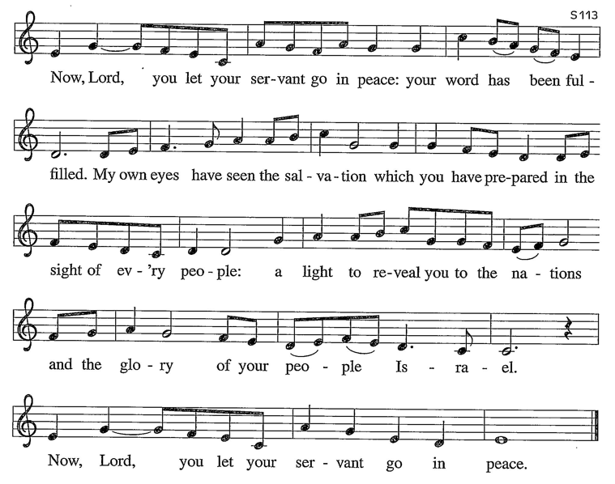

PRAYER AFTER COMMUNION
P God of our salvation, we give you thanks for this meal that restores our souls, reconciles us to you, and strengthens us for the journey. Through the body and blood of your Son, may we become Christ’s body in the world, bearing witness to your love for all creation, through Jesus Christ, our Savior and Lord.
C Amen.

BLESSING
P Receive the blessing of the holy Trinity: God, who calls all things into existence, Jesus Christ, who redeems us, and the Holy Spirit, whose breath sustains creation, ☩ bless you now and always.
C Amen.

SENDING HYMN “O Jesus, I Have Promised”, #810

DISMISSAL
WA Go in peace. Believe the good news.
C Thanks be to God.

POSTLUDE
--Thank you for worshiping with us today—

The following members assisted with today’s worship service with live streaming:
Altar Guild: Shron Tulio, Sue Dompkowski | AV Team: Terry & Debbie Hildebrand
Bulletin: Dawn Plyler ~ Cover Art: Lori Schneider | Cantor: John Grunewalder | Music: Bud Esper, Director of Church Music; Kim Hawkins, Conductor, St. Luke Handbell Choir; St. Luke Voice Choir and St. Luke Handbell Choir | Communion Assistants: Dona Quinlan, Sherry Fitzsimmons | Crucifer: Jim Drake | Eucharistic Minister: Joyce Rivenburgh | Greeters: John & Anna Borchert | Lector: Sue Heitmuller Ushers: Wayne Huffman, Becky Overcash, Kenn Nelson, Beverly Werner
Worship Assistant: Kristen Killoran
NEW MEMBERS
Are you looking for a new church family? We’d love to help you connect with others in the church and grow in our Faith Community together. If you are thinking about joining St. Luke, please contact Pastor Eichorn at 610.393.7622 or pastoreichorn@stlukeoib.org or the Church office.
ALTAR FLOWERS
Please contact the church office to sponsor Sunday altar flowers.
Upcoming availability: March 22,29; April 5,12,19,26
PRAYER LIST MARCH 15, 2025
Steve Jewell, Arlene Cook, Amy Golden, Doug Thompson, Ron Spangler, Cade Michael Born, Norm Alloway, Mary Lou Mills, Norma Johnson, Phil Orsini, Jim Woodason, Floye Istui, Chuck Beardall, Jennifer Keating Dix, Joe Schloskey, Joan Ateschian, Rich Corradi, Judy Drake, Ashleigh, Donna Hunt, Beverly Dague, Mary Mason, the family of Bob Gross, people living in areas devastated by tornadoes, the people of Iran,
US servicemembers, all who are at war.
LUTHERAN LIFE
WELCOME VISITORS ~ We are delighted you visited St. Luke today. Please join us in the Fellowship Hall after worship services for green punch and treats.
FRIENDLY REMINDER ~ Saint Luke members, please sign in so we can accurately report attendance to our synod and to our guests/visitors, we can show our appreciation to you. We love you and thank you for being a part of today’s service!
SUPPORTING ST. LUKE MINISTRIES
- EASTER FLOWERS ~ Lilies and Gerbera Daisies $10/each. Due TODAY, March 15.
- INGRAM PLANETARIUM OUTING ~ Monday, March 16 at 10:30am. Cost is $8/pp.
- LMM BREAKFAST ~ Grab your tickets TODAY at $10/each to enjoy the breakfast on Sunday, March 22, 8am-9:15am. See Tony Dompkowski.
- WOSL DINNER & MEETING ~ Join the WOSL Monday, March 16 at 5pm in the fellowship hall. Following the meal, we are excited to welcome Kathryn Hand, who will share insights from her mission work in Tanzania. We hope to see you there!
- PRAYER VIGIL FOR OUR NATION ~ Tuesday, March 17, 3pm-5pm, Sanctuary. All are welcome at any time during these hours. The sanctuary is open.
- THE GREATER SHALLOTTE MINISTERIAL ASSOCIATION LENTEN WORSHIP SERVICES ~ The Lent series continues. Join us!
- March 18 ~ Seaside United Methodist Church
- March 25 ~ Saint Luke Lutheran Church
- ST. LUKE LENT SEASON ~ WEDNESDAY SERVICE WITH SUPPER ~ Join us at 5pm in the Sanctuary for the next chapter of “24 Hours That Changed The World – the Crucifixion” and at 5:30pm in the fellowship hall for supper.
- WOSL Annual Patriotic Charity Luncheon! Join us on Saturday, April 25, (doors open at 11am and lunch is at Noon) for the WOSL annual charity luncheon! This year, we are proud to support local Brunswick County organizations, Waves 4 Kids (waves4kids.org) and Street Reach (bcstreetreach.org), with proceeds from our charity raffle. Thank you for your support and let’s make this year AMAZING!
- We need your help to make this raffle a success! We are seeing donations of: Gift cards, themed baskets, donated services or products from local businesses you frequent. Please have all donations turned in by Sunday, April 12. Sponsorship Letters & Tickets: (letters are available in mailbox #13 and contact Sue Dompkowski for tickets.
- SOCIAL MINISTRY COMMITTEE ~ Support the Lutheran Disaster Response (LDR) Carolinas by donating $25 gift cards for Home Depot, Lowe’s, and Walmart “Welcome Home” gift baskets now through Easter. ~Thank you, Sue Heitmuller.
- NOTES OF THANKS
Banners ~ We extend a heartfelt thank you to Karen Ernst for creating the beautiful banners gracing our sanctuary this Lenten season. Gratefully, Jim Hughes, Pastor Eichorn, the Church Council, and the parishioners of Saint Luke.
- Labor of Love/Quiet Work ~ We are profoundly grateful to our Prayer Shawl Ministry for countless hours of knitting and crochet. Next Sunday during worship we will dedicate these beautiful, prayerful shawls. Each stitch is a prayer for strength and healing, and these “wearable hugs” are tangible expressions of God’s love, comfort, and peace - the dual blessing of prayer and touch. Thank you for sharing your gifts to surround our church family with God’s comfort and protection. ~Blessings, Pastor Eichorn, the Church Council, and the parishioners of Saint Luke.

This Week at Saint Luke ~ March 2026
Sunday, March 15 9am Adult Sunday School
Fourth Sunday in Lent 10am Worship Service with live streaming
Dedication ~ Banners
11am Fellowship with green punch & treats!
All are welcome!
Monday, March 16 3pm MexTrain
5pm WOSL Dinner & Meeting
Tuesday, March 17 10:30am Listening Group
1pm Bridge
1pm Special Cantata Rehearsal (Voice Choir)
3pm-5pm Prayer Vigil
Wednesday, March 18 Morning Prayer postponed due to GSMA at Noon
Noon Seaside United Methodist Lent & Luncheon
5pm St. Luke Lent Service & Supper
6pm Handbell Choir
7pm Voice Choir
Thursday, March 19 1pm Council Meeting ~ Library
Friday, March 20 1st Day of Spring
Sunday, March 22 8:15am LMM pancakes & sausage breakfast
9am Adult Sunday School
Fifth Sunday in Lent 10am Worship service with live streaming
Dedication ~ Prayer Shawls
11am Fellowship ~ All are welcome!
Scripture Readings ~ March 22, 2026 ~ Fifth Sunday in Lent
Ezekiel 37:1-14 | Psalm 130 | Romans 8:6-11 | John 11:1-45

